Driving Foundation — System Overview v. 0.3

Overview
This document is the spine of a set. It does not describe a game. It describes the shared driving layer that future robot mini-games are built on top of, the same way the Matchmaking & Lobby System describes a shared session layer rather than a shipped feature of any one title.
The set exists as separate documents rather than a single design bible for a practical reason. The modules below have different reviewers and different readiness dates. The drift and boost economy is a feel question that will churn through many playtests before it settles. The networking requirements are an engineering question. Bundling them into one document means the whole thing stays in draft until the slowest section lands, and no one can start building against the parts that are already stable. Split into modules, each one can be signed off independently and referenced by the others.
What this spine carries is the connective tissue a pure document set would otherwise lose: the feel target, the shared vocabulary, the module map, and the record of what has already been decided. No mechanic is specified here. If a number appears in this document, it is repeated from a module document and that module is the source of truth.
The reference point is Crash Team Racing, not Mario Kart, and that is a mechanical commitment rather than a matter of tone. Mario Kart charges a drift automatically and grants a fixed boost when the player releases it, under a hard top-speed ceiling. Crash Team Racing asks the player to hit a button inside a timing window, punishes a mistimed press, and lets chained boosts carry a player above nominal top speed for as long as they keep the chain alive. The first is a system a player performs. The second is a system a player plays. This foundation is built as the second, with a generous, tunable release window so that the timing is achievable for a casual player without the depth being removed.
Not every game on this foundation is a race. A capture-the-flag arena where robots bump each other to steal the flag uses the same drive model, the same drift input and the same collision system, but wants almost the opposite tuning: rotation over top speed, heavy contact over clean lines. The foundation is designed around that from the start rather than being a racing system that arena games work around.
All networking decisions live in the Matchmaking & Lobby System document, not here. That document carries the full set of technical networking options with their consequences, for the development team to rule on during implementation. The Vehicle Network Sync document in this set states what the driving foundation requires from whatever approach is chosen; it does not choose.
This is a young platform. Every numeric value across this document set is provisional and marked as such. The structural decisions — the layer model, the rotation-versus-reserve split, the profile resolution order, the determinism contract — are the load-bearing parts and are what the team should focus review on.

Platform Context
Two constraints set outside this document set, recorded here because several modules depend on them.
PC only. This foundation targets keyboard and gamepad on desktop. There is no touch control scheme, no tilt input and no mobile-specific behaviour anywhere in the set.
Robots are chosen before a game launches, and customisation already exists. The robot roster and its customisation system are pre-existing platform features carried over from prior work. A player picks and customises their robot ahead of any mini-game, which makes the robot a platform-level identity rather than a per-game one. Handling Profiles is written against that fact.

Design Pillars
These are the standards every module in the set is checked against. A mechanic that fails one of them does not ship into the foundation.
- Speed is earned, not granted. A player who understands the drift system is meaningfully faster than a player who only holds the accelerator. The gap between those two players is a tuning dial, never zero.
- The floor is low and the ceiling is high. A young player pressing boost roughly when the robot lights up should succeed. The same track should still reward a player who chains drifts perfectly. These are the same build, not two difficulty modes, and the mechanism is a generous window rather than an assist system.
- Failure is legible and recoverable. A player who spins out, misses a boost window or hits a wall understands what happened and is back in play in seconds. Nothing in this foundation puts a player in a losing spiral they cannot read their way out of.
- Contact is comic, not violent. Robots bump, spin and right themselves. No hit reads as damage or injury. This is a hard constraint, not a stylistic lean.
- Every feel value is authored data, not code. A designer retunes weight, grip, drift charge rate or surface behaviour by editing a ScriptableObject asset in the Unity inspector, without an engineer and without a rebuild.
- The same input vocabulary works in every game on the foundation. Accelerate, brake, steer, hop and drift-boost mean the same thing in a race and in an arena. A player who has learned one robot driving game can drive in all of them.
- Deterministic first. Anything that affects simulation resolves identically on every peer for a given tick and input. Nothing feel-critical is client-local. This constraint binds every module in the set regardless of which networking approach the team selects.

The Layer Model
A mini-game does not implement driving. It selects a handling profile, supplies track data, and takes control at the point where the foundation stops.
Layer | What it is | Owns | Document
Layer A — Input & Camera | Device input resolved into a per-tick input struct, plus camera behaviour | Control mapping, camera as a speed and state cue | Input & Camera
Layer B — Drive Model | The per-tick physics of a single robot chassis | Acceleration, top speed, steering, grip, slope, airborne behaviour | Vehicle Drive Model
Layer C — Drift & Boost | The skill layer that modifies Layer B | Hop, slide, rotation authority, reserve charge, release window, chains | Drift & Boost Economy
Layer D — Contact & Recovery | What happens when two chassis or a chassis and the world meet | Bumping, wall behaviour, spin-out, respawn, out-of-bounds | Collision, Contact & Recovery
Layer E — Handling Profiles | The ScriptableObject data layer that parameterises A through D | Profile schema, presets, robot stats, overrides, surface channels | Handling Profiles & Surfaces
Layer F — Track Data | The authoring contract for a drivable space | Drivable geometry, volume, anchors, surface tagging. Spline deferred | Track Data & Spline System
Layer G — Network Requirements | What the foundation needs from the networking layer | Determinism contract, replicated state list, authority requirements | Vehicle Network Sync
Layer H — Game Rules | Win conditions, scoring, objectives | Nothing in this set — this is the mini-game itself | Per-game design document
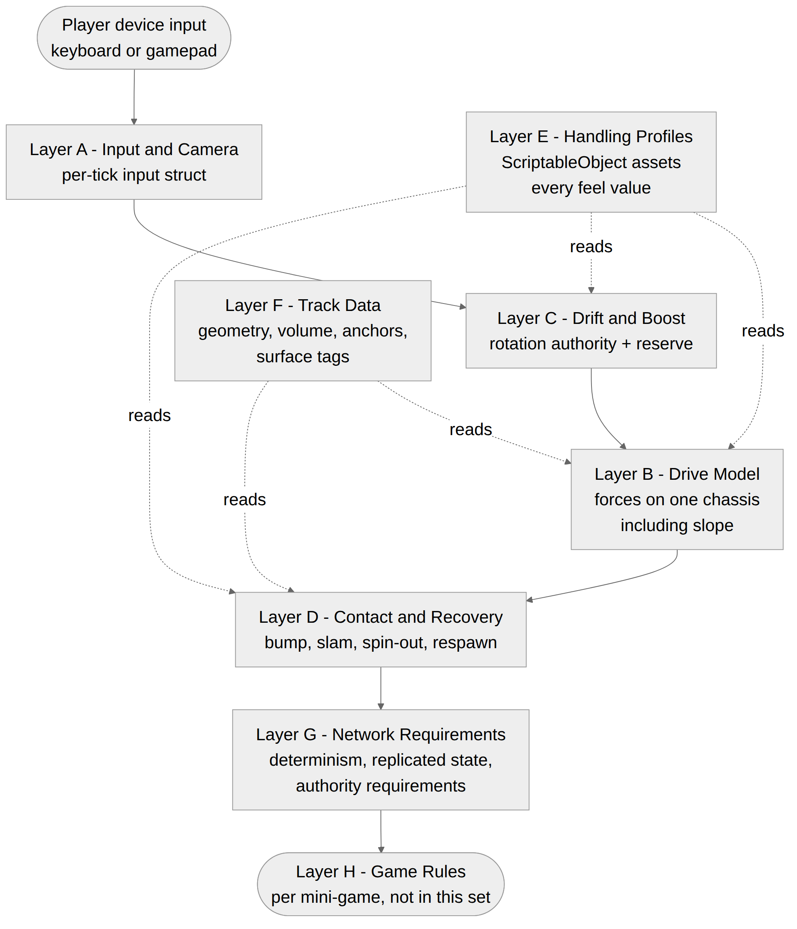
Where the foundation stops. The foundation delivers a robot that drives, drifts, boosts, bumps and recovers, inside a tagged drivable space, in sync across peers. It has no opinion on why the player is driving. Lap counting, placement, flag carrying, scoring, round timers, minimaps and results screens all belong to Layer H, which is per-game.

The Module Map
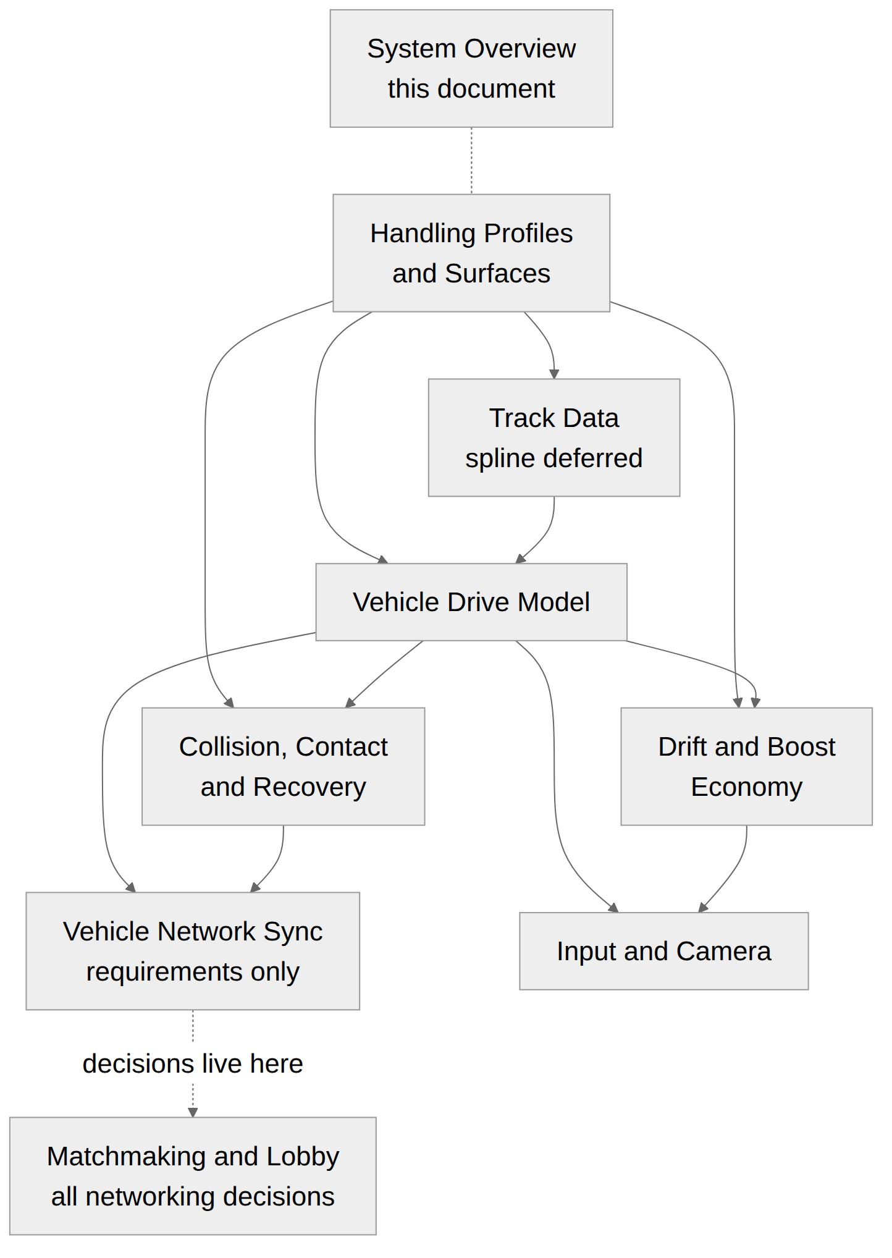
Document | Owns | Depends on | Review type
01 System Overview (this document) | Pillars, layer model, vocabulary, decision record | Nothing | Direction
02 Handling Profiles & Surfaces | ScriptableObject schema, presets, robot stats, surface channels | Nothing — it is the data contract others read | Design and tools
03 Vehicle Drive Model | The single-chassis physics base layer | Handling Profiles for its values | Design and engineering
04 Drift & Boost Economy | Rotation authority, speed reserve, release window, chains | Drive Model, Handling Profiles | Design, high iteration
05 Collision, Contact & Recovery | Chassis-to-chassis and chassis-to-world contact, spin-out, respawn | Drive Model, Handling Profiles | Design and engineering
06 Track Data & Spline System | Drivable geometry, volume, anchors, surface tagging | Handling Profiles for surface identifiers | Tools and level design
07 Input & Camera | Control mapping, camera behaviour | Drive Model, Drift & Boost | Design and UX
08 Vehicle Network Sync | Determinism contract, replicated state, authority requirements | Drive Model, Collision | Engineering
On the numbering of these documents. The file numbers are a reading order, not a build schedule. They run 00 to 08, starting with the Matchmaking & Lobby System because it precedes a match chronologically and because the networking rulings it carries block work across the whole set. Two documents sit where their numbers do not describe when the work happens:
- 08, Vehicle Network Sync, reads best last, because its replicated-state list names values that only make sense once the modules producing them have been read. Its determinism contract, however, must be understood before any simulation code is written — building to determinism is far cheaper than retrofitting it. Read it eighth; consult it first.
- 07, Track Data & Spline System, is tools and level-design work with no dependency on the simulation modules beyond the surface tag list. It can begin immediately and run in parallel with everything else.
Recommended build order. Handling Profiles and Vehicle Drive Model first, since every other module reads from them. Vehicle Network Sync’s determinism contract should be read before any simulation code is written, because retrofitting determinism is far more expensive than building to it. Drift & Boost and Collision after that, both expected to iterate heavily. Input & Camera last. Track Data can proceed in parallel with any of them.

Shared Vocabulary
Seven documents referring to the same thing by different names is the most predictable failure mode of a document set. These terms mean exactly this, everywhere in the set.
Term | Definition
Chassis | One drivable robot. The physical unit the drive model simulates. Not “kart”, not “vehicle”, not “car” — the platform’s characters are robots and the term should not import expectations from a car game
Drive Model | The per-tick simulation of a single chassis. Layer B
Profile | A ScriptableObject asset holding every feel value for a chassis. Layer E
Robot stats | A platform-level per-robot delta on a profile. The heavy robot is heavy in every mini-game
Rotation authority | How much extra yaw a chassis is granted while drifting. One of the two outputs of the drift system
Reserve | Stored boost energy accumulated while drifting. The other output of the drift system. Measured in charge units, not seconds
Release window | The span after a drift ends during which a boost press converts reserve into speed
Chain | Two or more successful boosts taken without the chassis returning to a neutral, non-boosting state
Scrub | Speed lost to lateral slip. A drift that scrubs badly is slow even if it charges well
Grade | The signed slope under the chassis. Positive climbing, negative descending
Surface | A tagged region of drivable geometry that multiplies specific channels of the active profile. Ice, dust, oil
Grounded / airborne | Whether the chassis has contact with drivable geometry this tick. Determines which force model applies
Spin-out | The recovery state after a heavy contact. Control is reduced for a defined duration, then returns. Never a full loss of control
Tick | One fixed-step simulation update. The unit of time for every simulation value in this set
Feel value | Any number a designer is expected to tune. Distinct from engineering constants, which are not exposed in profiles

Resolved Decisions
Recorded here so the development team can see what is settled and does not need re-litigating. Each is implemented in the module named.
Decision | Ruling | Module
Assist system | Not built. No auto-accelerate, steering assist, wall nudge or drift entry assist. Accessibility is handled by a generous, tunable boost release window instead. Revisit only if playtests show the game is too hard for a young audience | Input & Camera, Drift & Boost
Drift and boost model | Crash Team Racing model. Tap inside the release window, three charge stages, missing the window loses the reserve, chaining uncapped | Drift & Boost
Charge stages | Three, with generous window timing | Drift & Boost
Charge meter | None. Stages are read from the chassis itself, differentiated by brightness, audio pitch and particle density rather than colour alone | Drift & Boost
Slipstream | Not built. Excluded from the foundation entirely; a racing game will solve catch-up its own way | Drift & Boost
Module shedding | Not built. Robots keep their appearance throughout play. A future mini-game that specifically wants it can build it for itself | Collision
Recovery states | Spin-out only. The lighter Wobble state is removed | Collision
Respawn | Clears the boost chain and the reserve | Collision, Drift & Boost
Reverse | Included | Drive Model
Mass and inertia | Independent values. Mass governs who wins a bump; inertia governs how sluggish the robot feels | Drive Model
Slope | Modelled. Uphill reduces attainable top speed, downhill allows a modest overspeed, both scaled per robot | Drive Model
Low-speed floor | Not built now. Revisit after testing, before a racing game is started | Drive Model
Robot archetypes | Platform-wide. Robots are chosen and customised before a mini-game launches, so a robot is a platform identity. Whether robots also differ in stats is a designer decision, supported by the data model either way | Handling Profiles
Profile storage | Unity ScriptableObject assets, editable in the inspector, duplicated to create presets | Handling Profiles
Per-preset surface overrides | Supported from the start, so that power-ups such as a dropped oil slick can behave differently per game | Handling Profiles
Spline and checkpoints | Deferred to nice-to-have. Built when a racing mini-game is greenlit. Everything else in Track Data ships now | Track Data
Moving drivable geometry | Not built. May be revisited if a future mini-game needs it | Track Data
Arena drivable volume | Required, even for sealed arenas, as the safety net for geometry failures | Track Data
Track tooling | Build the foundation tooling, including the respawn coverage visualiser and an in-editor validation panel | Track Data
Control schemes | Keyboard and gamepad only. PC target. No touch, no tilt | Input & Camera
Corner look-ahead camera | Not built. Blind corners are a level design concern, and racing games will carry a minimap | Input & Camera
Heads-up display | None in the foundation. Per-game HUD is Layer H | Input & Camera
Robot stats | Appearance only. Every robot drives identically; the roster is a cosmetic identity. The data model supports adding differentiation later with no schema change | Handling Profiles
Race Director | Not built. Lap counting, placement, countdown and results are per-game. Deferred alongside the spline system, on the same trigger — a greenlit racing mini-game | Not in this set
Skill-based matching | Not built. Scheduled revisit once there is live matchmaking volume | Matchmaking & Lobby System
In-app friends list | Not built. Public Rooms cover playing alongside a friend against strangers, with no social graph | Matchmaking & Lobby System
Account and identity | Persistent accounts. Players sign in to the platform launcher, so player lists show account names and a player reference carries a persistent identity | Matchmaking & Lobby System
Party size | Declared per game at build time. No platform-wide tiers. A future team-based mode is a known gap to be specified when one is proposed | Matchmaking & Lobby System
Local multiplayer | Not built | Matchmaking & Lobby System
Late join and rejoin | Not supported. Everyone in the lobby starts together; a player who leaves is gone for that round | Matchmaking & Lobby System
All networking decisions | Open, and consolidated into the Matchmaking & Lobby System document for the development team to rule on | Matchmaking & Lobby System

Open Questions
None. Every design question raised across this document set has been ruled on, and the rulings are recorded in the table above and in the module documents that implement them.
The only decisions still outstanding anywhere on the platform are the technical networking rulings N1 to N10, which live in the Matchmaking & Lobby System document and belong to the development team. That is by design: this set states what the driving simulation requires and leaves the implementation choices to the people building it.
Two items are recorded as deliberate deferrals rather than open questions, so that their absence reads as a decision:
- The low-speed floor in the Vehicle Drive Model. Not built now; revisit after the first round of testing and before work starts on a racing mini-game. It is the most effective remaining forgiveness lever now that no assist system is being built.
- The spline system and a Race Director. Both deferred on the same trigger — a greenlit racing mini-game — because both are only useful to a game that measures progress along a route, and both should be written against a real racing game’s requirements rather than guessed at.

Integration Notes
- Requires: The existing robot roster and customisation system. A resolved set of networking rulings from the Matchmaking & Lobby System document before the network layer is implemented.
- Integrates with: The Matchmaking & Lobby System, which delivers a connected session with a known player list into which this foundation’s gameplay scene is loaded. This set begins where that document’s StartMatch ends.
- Affects: Every future mini-game with driving in it, whether or not it is a race. The environment authoring pipeline, since Track Data introduces surface tagging as a requirement on drivable geometry.
- Does not cover: Game rules of any kind. Weapons or pickups — though Handling Profiles’ transient modifier and per-preset surface support is deliberately built so that a power-up such as a dropped oil slick needs no foundation change. AI or bot drivers. Audio and visual direction beyond the legibility requirements each module states.
- Follow up: Re-baseline the whole set after the first playable prototype, and specifically after the first arena-shaped mini-game exercises the non-racing path, which is the least proven assumption in this document.

Success Metrics
- A new mini-game can produce a driving prototype by selecting a profile preset and supplying track data, with no code written against the foundation
- A designer can change how a chassis feels by editing a ScriptableObject, without an engineer and without a rebuild
- A player who has learned one robot driving game can drive competently in a second one on first contact
- An arena-shaped mini-game and a racing mini-game run on the same drive model, differing only in profile and track data
- No term in this set is used with two different meanings across two documents
- No networking decision is made inside this set

Implementation Checklist
A milestone breakdown of everything specified in this document, so that a developer can confirm nothing was missed. Milestones are ordered so that each one is testable before the next begins. An item marked [D] is a decision or confirmation rather than code.
This document specifies no mechanics, so its checklist is a readiness gate for the set as a whole rather than a build list. It is the checklist a lead runs before and after the driving foundation is built.

M0 — Before any code is written
☐ Every developer on the foundation has read this document
☐ The networking rulings in the Matchmaking & Lobby System (N1 to N10) are settled
☐ Vehicle Network Sync’s determinism contract has been read by everyone touching simulation code
☐ Tick rate is fixed, and fixed before the Drift & Boost tuning pass
☐ The Resolved Decisions table has been reviewed and nothing in it is being re-litigated
☐ Confirmed that no design question in this set is outstanding — only N1 to N10 remain

M1 — Shared conventions in place
☐ Every term in the Shared Vocabulary table is used with exactly one meaning in code
☐ “Chassis” is the term in use, not kart, vehicle or car
☐ Every feel value lives in a ScriptableObject and none are hard-coded
☐ All profile values are authored in per-second terms and converted at load
☐ No module reads render-frame delta time except the camera

M2 — Layer boundaries respected
☐ Layer A produces the input struct and nothing downstream knows which device produced it
☐ Layer B is the only place chassis velocity is written during the simulation step
☐ Layer C modifies Layer B rather than replacing any part of it
☐ Layer D runs strictly after Layer B has written, never during
☐ Layer E is read-only at runtime and never written to
☐ Layer F carries no game rules
☐ No game rule, score, lap or objective exists anywhere in the foundation

M3 — Pillar verification, on a playable build
☐ A player who drifts well is measurably faster than one who does not
☐ A player who never drifts can complete a round and enjoy it
☐ Every failure state is readable and recovers within seconds
☐ No contact at any strength reads as damage or injury
☐ A designer changed a robot’s feel without an engineer and without a rebuild
☐ The same five inputs behave identically across every mini-game built so far
☐ The determinism soak test passes

M4 — Reusability sign-off
☐ A second mini-game reached a driving prototype by selecting a preset and supplying track data, writing no code against the foundation
☐ An arena-shaped game and a race-shaped game run on the same drive model, differing only in profile and track data
☐ No term in the set is used with two meanings across two documents
☐ No networking decision was made inside the driving document set

All numeric values across this document set are provisional and subject to a dedicated tuning pass once a playable prototype exists to tune against.

